**TEST PLAN**

1. Create a Student object with the default constructor
2. Create a Student object with all non-default constructor
3. Test all get methods
   1. getName
   2. getPhoneNo
   3. getSubject
   4. getStore

first positv than negative tests

1. test all set Methods
   1. setName
   2. setPhoneNo
   3. setSubject
2. Test display methods

**Student**

**name: string**

**phoneNo: string**

**subject: string**

**student()**

**student(String, String, String)**

**display()**

**getName(): String**

**getPhoneNo(); String**

**getSubject(): String**

**getStore(): String**

**setName(String)**

**setPhoneNo(String)**

**setSubject(String)**

**ACTUAL TEST**

**Test 1**

Create a Student object with the default constructor

Test Data

* No input

Expected Results:

* name: “student”
* phoneNo: “999999999”
* subject: “subject”

Actual Result:

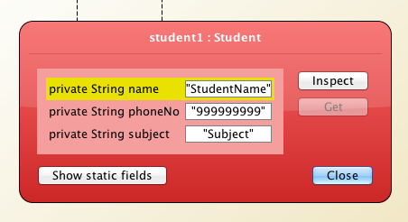

**Test 2**

Create a Student object with all non-default constructors

Test Data

* name: Andy Cheng
* phoneNo: 987654321
* subject: Computing

Expected Results:

* name: “Andy Cheng”
* phoneNo: “987654321”
* subject: “Computing”

Actual Result:

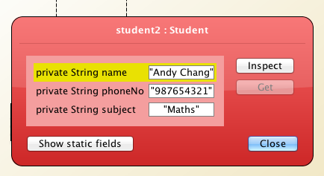

**Test 2 b) Negative testing**

Create a Student object with invalid attributes where possible

* name cant be blank
* phone number has to start with a 9
* phone number has to be 9 digits long
* subject can only be on of the 3

**Testing Blank Name**

Test Data

* name: “ ”
* phoneNo: “998877665”
* subject: “Maths”

Expected Results:

* name: “student Name”
* phoneNo: “998877665”
* subject: “Maths”

Actual Result:

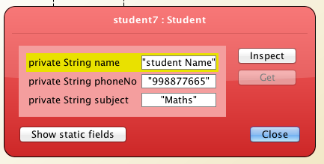

**Testing Blank wrong numbers**

**With 8 digits**

Test Data

* name: “Andy Cheng”
* phoneNo: “99887766”
* subject: “Maths”

Expected Results:

* name: “student”
* phoneNo: “999999999”
* subject: “Maths”

Actual Result:

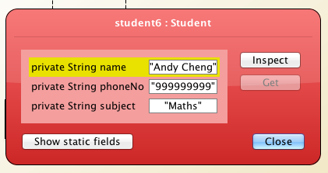

**With 10 digits**

Test Data

* name: “Andy Cheng”
* phoneNo: “9988776655”
* subject: “Maths”

Expected Results:

* name: “student”
* phoneNo: “999999999”
* subject: “Maths”

Actual Result:

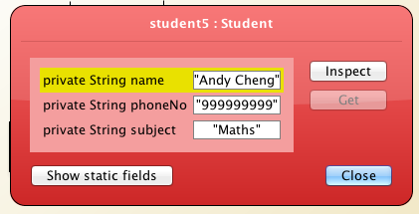

**Testing Blank false number not beginning with 9**

Test Data

* name: “Andy Cheng”
* phoneNo: “887766554”
* subject: “Maths”

Expected Results:

* name: “student”
* phoneNo: “887766554”
* subject: “Maths”

Actual Result

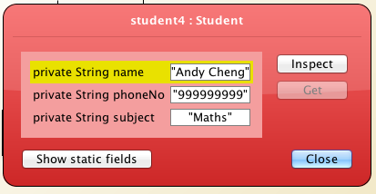

**Testing with letter instead of number**

Test Data

* name: “Andy Cheng”
* phoneNo: “a”
* subject: “Maths”

Expected Results:

* name: “student”
* phoneNo: “999999999”
* subject: “Maths”

Actual Result:

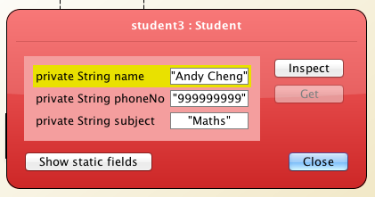

**Testing wrong subject (Sport)**

Test Data

* name: “andy”
* phoneNo: “998877665”
* subject: “sport”

Expected Results:

* name: “andy”
* phoneNo: “998877665”
* subject: “subject”

Actual Result:

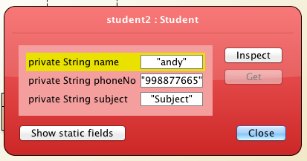

**Test 3**

**Test all get Methods**

* 1. **getName**

test Data

* no data

Expected result:

Return the default constructor name which is “StudentName”

Actual Result:

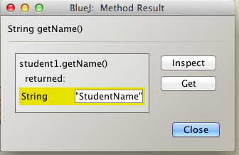

**getPhoneNo**

test Data

* no data

Expected result:

Return the default constructor phoneNo which is “999999999”

Actual Result:

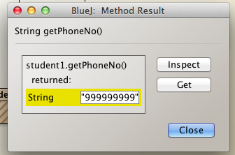

**getSubject**

Test data

* no data

Expected result:

Returns the default constructor subject with is “subject”

Actual Result:

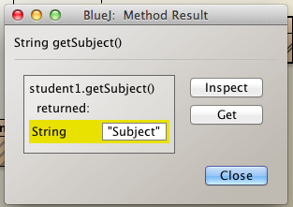

* 1. **getStore**

Test Data

* no data

Expected result:

Returns a string with the default constructor

“StudentName, 99999999, Subject”

Actual Result:

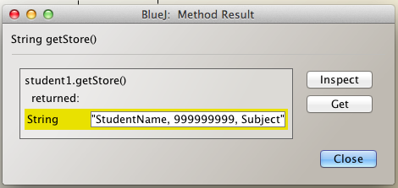

**Test 4**

**Test all set Methods**

1. **setName**

Test data

* Set name “andy”

Expected result:

Name string: “andy”

Actual Result:

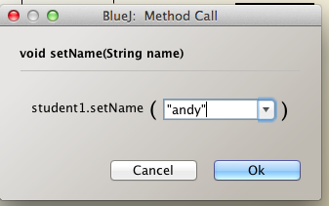

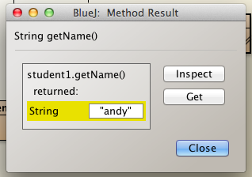

1. **setPhoneNo**

Test Data

* set phoneNo to 998877665

Expected result:

String : “998877665”

Actual Result:

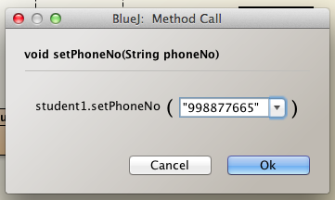

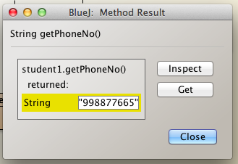

1. **setSubject**

Test Data

* set subject to Maths

Expected result:

String : “Maths”

Actual Result:

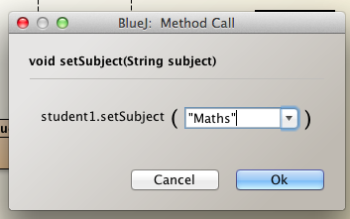

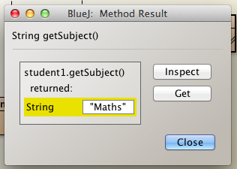

**Negative-get-Testing**

**Testing Blank Name**

Test Data

* setName: “”

Expected Results:

* getName: “student Name”

Actual Result:

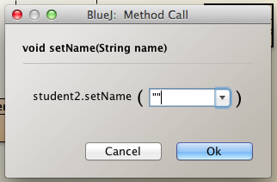

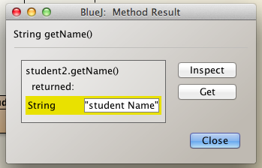

**Testing Space as Name**

Test Data

* setName: “”

Expected Results:

* getName: “student Name”

Actual Result:

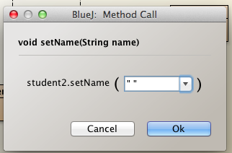

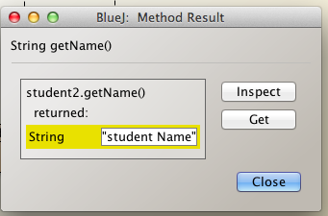

**Testing 8 digits phoneNo**

Test Data

* setPhoneNo: “99887766”

Expected Results:

* getPhoneNo: “999999999”

Actual Result:

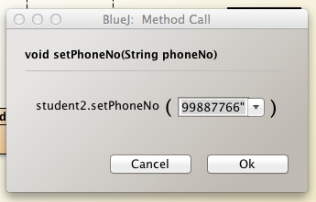

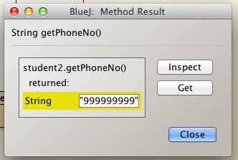

**Testing 10 digits phoneNo**

Test Data

* setPhoneNo: “9988776655”

Expected Results:

* getPhoneNo: “999999999”

Actual Result:

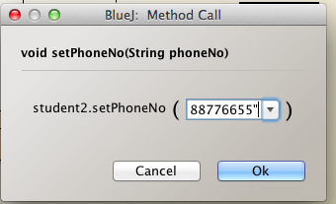

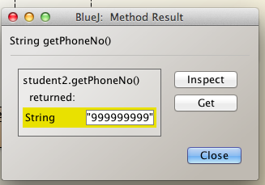

**Testing empty phoneNo**

Test Data

* setPhoneNo: “”

Expected Results:

* getPhoneNo: “999999999”

Actual Result:

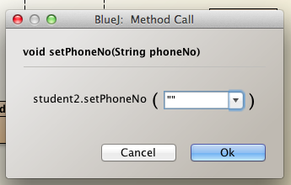

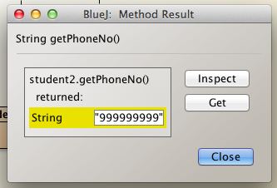

**Testing letters as phoneNo**

Test Data

* setPhoneNo: “jash”

Expected Results:

* getPhoneNo: “999999999”

Actual Result:

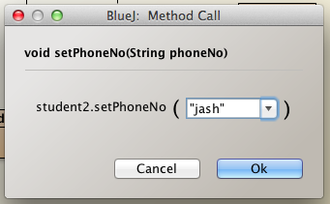

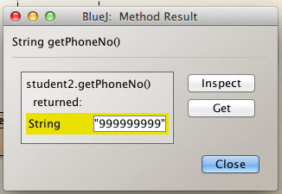

**Testing starting number that is not 9 as phoneNo**

Test Data

* setPhoneNo: “887766554”

Expected Results:

* getPhoneNo: “999999999”

Actual Result:

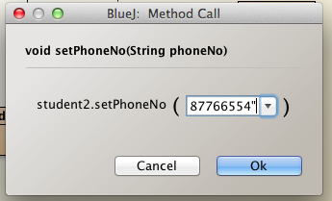

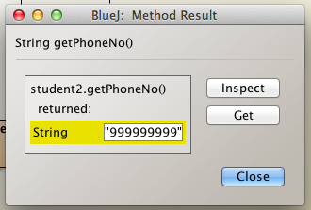

**Testing empty subject**

Test Data

* setSubject: “”

Expected Results:

* getSubject: “subject”

Actual Result:

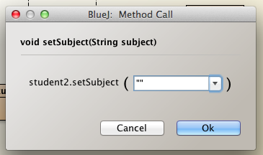

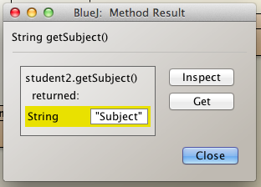

**Testing subject that’s not existing (Maths,Englisch,Computing)**

Test Data

* setSubject: “sport”

Expected Results:

* getSubject: “subject”

Actual Result:

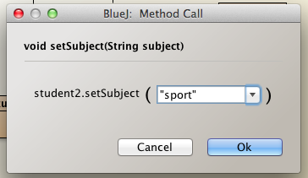

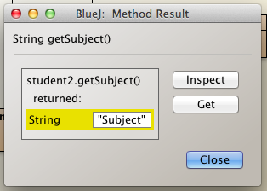

**Test 5**

Test Display Method

Test Data

* no test data

Expected result

* Start the terminal and display the default values
  + Student name: StudentName
  + Student number: 999999999
  + Subject: Subject

Actual Result

